Liam Cauquil (1394106)

Dr. Chen

BIOE 1331 – Project Report

Due: May 8, 2016

Electrocardiogram Data Analysis

The audience’s anxiety intensifies as their wounded hero’s life line beeps ever faster. Doctors are frantic to help the on screen character as he starts to lay off. The cinema is left in a state of awe when the familiar drone of the flat line announces the inescapable truth. Everyone remembers the rhythmic hills and cold beeps of their hero’s heart ending. Yet the crucial data shown in those few hills help determine health, anxiety and stress. An ECG is a medical instrument that records the heart’s electrical impulses and muscle contractions. People still call Electrocardiogram EKG due to the German translation Elektro-kardiographie, however both ECG and EKG are synonymous. Electrodes are placed on the chest, sometimes more on the ankles and shoulders, which then run through the processing unit. It then prints or displays on a screen the familiar hills and crests that makes up the ECG. The hub center contains the algorithms necessary to interpret the needed data. Fundamentally, the ECG filters out extra noise that clouds the original signal, then proceeds to plot out where certain peaks and time intervals are to help calculate pulse rates and muscle contractions signals.

In this project, two sets of 10-hour raw ECG sessions had to be filtered and processed to calculate the patient’s average pulse rate and heart rate variation. The data given had a 60 Hertz power line noise that prevented accurate analyses for algorithms to interpret. Therefore, a Butterworth band pass filter intervaled at 59 to 61 Hz was used to adjust for the noise with an additional Savitzky-Golay filter to help smooth the extra deviations. With the sampling frequency, times of each R peak were used to get the RR intervals. This helps determine how long each cardiac cycle took to complete, which can then be averaged. Using the formula

$$Average Pulse Rate=\frac{\left(60*Sample Frequency\right)}{Average RR intervals}$$

, the average heart rate for each patient was calculated then plotted in with the filtered data. Then, using the RR intervals, the heart rate variation was calculated between each complete cardiac cycle and plotted over the filtered graphs.

Below are results for Patient 2 as an example after executing the methods described above. First image shows the unfiltered data. Second image shows Patient 2 filtered with R wave peaks and the Average Pulse Rate included within the graph. The third image shows the Heart Rate Variation for each completed cardiac cycle.

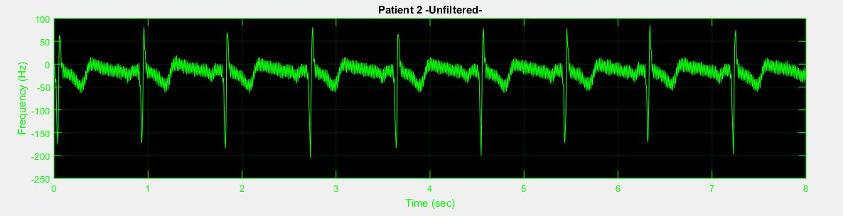

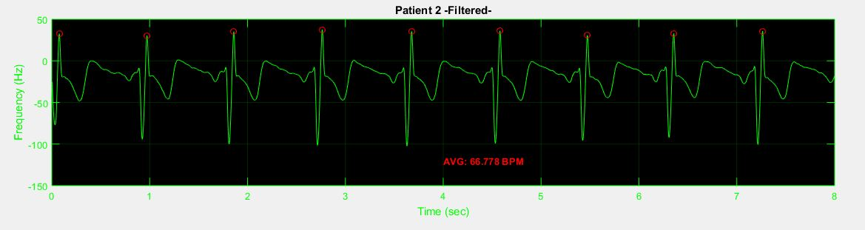

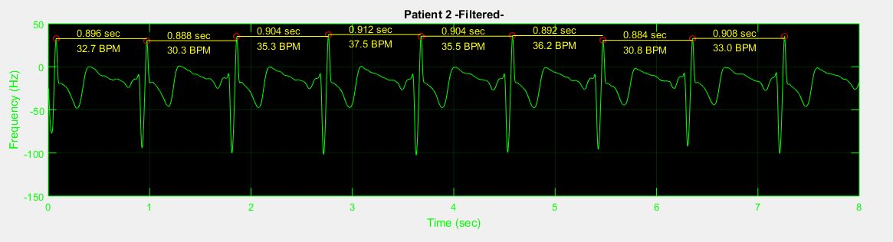

Issues that posed multiple problems for analyzing the data accurately was that at certain times, the data had a disruptive period. This small section of unrecognizable noise had to be balanced with extra scrutiny by the filters so they can get the most accurate possible data. Furthermore, sections on the raw input that had very high levels of interference have a 20% error as the Savitzky-Golay had to compensate for the radical noise. However, the R peaks during those times where not changed as the data after filtering with the band-pass was amplified to find the correct time intervals for each peak. These times were then used to search where along the pre-filtered data the value of the R wave peak at.

This project used multiple different skills of analyzing data, from filtering data points, plotting correct intervals and finding the correct peaks for calculations. Every day, bio-signal processes are used to help save lives and rehabilitate others. Moviegoers have come so used to hearing the familiar beeps of the ECG that they define themselves experts in cardiology. Yet, the intricate skills used to read them makes doctors the experts in helping others. It is the duty of the engineer to deliver working programs so that hospitals can help maintain a lifeline. Building an ECG takes an enjoyment of data analysis and innovative algorithms. Yet for now, let us hope that the next few characters that we have fallen in love with on the big screen never have to leave the story with the dreadful flat line that is inevitable death.

Works Cited

Wedro, Benjamin, MD. "What Is an Electrocardiogram (ECG, EKG)?" *EMedicineHealth*. EMedicineHealth, 17 Feb. 2016. Web. 08 May 2016. <http://www.emedicinehealth.com/electrocardiogram_ecg/article_em.htm#what_is_an_electrocardiogram_ecg_ekg>.

"ECG Timeline - History of the Electrocardiogram." *ECG Timeline - History of the Electrocardiogram*. N.p., n.d. Web. 08 May 2016. <http://www.ecglibrary.com/ecghist.html>.

"ECG vs EKG: What's the Difference." NeuroSky, 25 May 2015. Web. 05 May 2016. http://neurosky.com/2015/05/ecg-vs-ekg-whats-the-difference/